STATE OF WASHINGTON,  Prosecution  vs.  Casey Campbell,  Defendant. | NO. 2010-1-125  FACT SITUATION

On Friday, April 9, 2010, at 12:23 p.m., Detective Rory Riley of the Park Lane City Police Department received a call on the station’s anonymous tip line. The caller informed the detective that there was a suspicious container in a trash can at Park Lane High School. Detective Riley drove to the school to investigate the tip.

After informing the school’s administration of the situation, Detective Riley searched the campus. In one of the trash cans located on the dining patio next to the cafeteria, a clear container holding a liquid was found. Taped around the container were a wristwatch, wires, a battery, and a metal igniter strip. Detective Riley called for back-up and the bomb squad. The school was evacuated.

The next day, April 10, Detective Riley arrived at the police station early to continue the investigation of the container found at the school. Preliminary lab results identified the components of the liquid inside the container as paint thinner and Doxene, a common industrial cleaner.

At 9 a.m., Detective Riley was visited by Sawyer Simpson, a senior at Park Lane. Sawyer claimed to have information about the incident. Sawyer told Detective Riley that Sawyer saw Casey Campbell, also a senior at Park Lane, wandering around the dining patio before school started on Friday. Additionally, Sawyer told the detective that just last Wednesday, April 7, Casey told Sawyer, “You will be sorry that you ever picked on me.” Sawyer said that Casey thought that Sawyer and Sawyer’s group of friends were bullying Casey.

Sawyer Simpson is a member of a group of kids at Park Lane High known by the other students as The Crew. Sawyer Simpson is the leader of this group. Sawyer found that Casey’s R-Place page contained pictures of members of this group. Browsing through Casey’s page, Sawyer was troubled. Among others, Casey listed pyrotechnics as an interest. Additionally, Sawyer saw a drawing of Park Lane High School on fire with a person, labeled “Sawyer”, trying to get out of the burning building. Sawyer decided, based on all s/he’d seen, to tell his/her parents. Sawyer’s father drove Sawyer to the police station. Detective Riley interviewed Sawyer Simpson. Riley looked at Casey’s R-Place page and decided that, along with Sawyer’s statement, the police had enough evidence to obtain a warrant to search Casey’s house. A judge issued the search warrant.

Later that day, Detective Riley searched the Campbell house. In the garage, Riley found an almost empty container of paint thinner. In Casey’s room, on the wall, and in notebooks, Riley found drawings similar to the one on Casey’s R-Place page, as well as other art done by Casey.

With the paint thinner and drawings in hand, Detective Riley arrested Casey. Casey was charged with attempted murder in the first degree and malicious placement of an explosive in the first degree..

PHYSICAL EVIDENCE

Only the following physical evidence may be introduced at trial.
- Exhibit A, diagram of Park Lane High School.
- Exhibit B, Casey Campbell’s R-Space page.
- Exhibit C, a diagram of the device found at Park Lane High School.

STIPULATIONS

Stipulations shall be considered part of the record. Prosecution and defense stipulate to the following:

- Exhibit A is the diagram of Park Lane High School; Exhibit B is a copy of Casey Campbell’s R-Place page; and Exhibit C is a diagram of the device found at Park Lane High School and represents the device immediately before being dismantled by Dr. Killian.

- Casey Campbell created and maintained the R-Place page as identified in Exhibit B and referenced in the fact statement and witness statements.

- Casey created the drawing as depicted in Exhibit B and the drawings/photos found in Casey’s room and R-Place page.

- The search of Casey Campbell’s house was a valid search and may not be objected to.

- Dr. Killian and Dr. Atkinson are qualified expert witnesses.

- Dr. Atkinson can testify to the lab report, and its absence may not be questioned.

- The chain of custody of the device found by Detective Riley at Park Lane High School is not in dispute.

- All physical evidence and witnesses not provided for in the case packet are unavailable and their availability may not be questioned.

- All witness statements were taken in a timely manner.

LEGAL AUTHORITY

United States Constitution
U.S. Constitution, Amendment I
Congress shall make no law abridging the freedom of speech, or of the press.

State Statutes
- A person commits first degree attempted murder when, with premeditated intent to cause the death of another, he/she takes a substantial step toward commission of the act.
- Malicious placement of an explosive in the first degree occurs when a person maliciously places any explosive device in, upon, under, against, or near any building, car, or structure with intent to commit a terrorist act. A terrorist act is one that significantly disrupts the conduct of government or of the general civilian population of the state or the United States, and that manifest an extreme indifference to human life.

Case Law
Brandenburg v. Ohio, 395 U.S. 444 (1969)
Facts: Brandenburg, a Ku Klux Klan leader, was convicted of making a speech advocating crime and violence as a means of accomplishing political reform.
Issue: Was Brandenburg’s speech protected by the First Amendment?
Holding: Yes. The court overruled the conviction because “the constitutional guarantees of free speech and free press do not permit a state to forbid advocacy of the use of force or of law violation except where such advocacy is directed to inciting or producing imminent lawless action and is likely to incite such action.”

Ginsberg v. State of New York, 390 U.S. 629 (1968)
Facts: Ginsberg operated a “Sam’s Stationery and Luncheonette” store. He was convicted of violating a New York statute prohibiting the sale to minors of certain material. This material was not considered obscene for adults.
Issue: Did the New York statute invade the First Amendment right of minors?
Holding: No. The court held that the statute did not invade the freedom of expression or other freedoms constitutionally guaranteed to minors. Two interests justify the limitations upon the availability of material to minors: (1) a parents’ claim to authority in their own household to direct the rearing of their children is basic to our society; and (2) the state has an independent interest in the well-being of its youth.

Miller v. California, 413 U.S. 15 (1973)
Facts: Miller conducted a mass mailing campaign to advertise the sale of illustrated “adult” books. He was convicted of violating a California statute that made illegal the knowing distribution of obscene material.
Issue: Is obscene material protected by the First Amendment?
Holding: No. The court reaffirmed an earlier decision that obscenity is not protected by the First Amendment. Additionally, the court held that obscenity may be subject to state regulation where the work appeals to the prurient interest in sex, and, applying contemporary community standards, it does not have serious literary, artistic, political or scientific value.

Rice v. Paladin, 128 F.3d 233 (4th Cir. 1997)
Facts: Relatives of murder victims brought a wrongful death action against the publisher of the book Hit Man: A Technical Manual for Independent Contractors. The book provided extremely detailed instructions on the planning, commission, and concealment of criminal conduct.
Issue: Was the book Hit Man entitled to First Amendment protection?
Holding: No. Hit Man was not entitled to First Amendment protection. The book methodically and comprehensively prepared its audience for specific crimes and thereby amounted to advocacy and teaching of concrete action.

Sable Communications of California, Inc. v. F.C.C., 492 U.S. 115 (1989)
Facts: Telephone service brought an action seeking injunctive relief from the Communications Act which imposed blanket prohibition on indecent as well as obscene interstate commercial telephone messages.
Issue: Did the act violate the First Amendment?
Holding: Yes. The government may regulate the content of constitutionally protected speech in order to promote a compelling interest if it chooses the least restrictive means to further that interest. In this case, the Communications Act, was not narrowly tailored to serve the compelling interest of preventing minors from being exposed to indecent telephone messages.

Schenck v. United States, 249 U.S. 47 (1919)
Facts: Schenck, a Socialist, sent leaflets to draftees denouncing the draft as unconstitutional and urging them to "assert their rights" and refuse to serve the interests of Wall Street. He was charged with conspiring to violate the Espionage Act of 1917, which prohibited acts obstructing the U.S. military effort. Schenck was convicted for corrupting a draftee. Schenck claimed the First Amendment protected him from conviction.
Issue: Were the leaflets sent by Schenck protected by the First Amendment?
Holding: No. The court upheld Schenck's conviction because Schenck's actions presented a clear and present danger to the country that outweighed Schenck's First Amendment rights.

United States v. Playboy Entertainment Group, Inc., 529 U.S. 803 (2000)
Facts: A cable television programmer challenged the Telecommunications Act, which required cable operators to completely scramble sexually explicit channels or limit the programming on such channels to certain hours.
Issue: Does the Telecommunications Act violate the First Amendment?
Holding: Yes. The Supreme Court held that the statute did violate the First Amendment. The restriction was content-based and therefore subject to strict scrutiny. The provision failed because although there is a compelling interest in preventing children from hearing and seeing the images available on these channels, the act was not the least restrictive means of achieving this goal. The programmer showed that alternative means could effectively accomplish the goal.
Detective Riley, Witness for the Prosecution

My name is Detective Riley. I am 37 years old and have been working for the Park Lane City Police Department for the last 13 years.

The morning of April 9, 2010, had been pretty slow. I had spent a few hours finishing up some reports when the Captain walked by and asked me to handle the tip line. I wasn’t too excited about this because we rarely receive calls on this line, but today was different. At 12:23 p.m., someone called from a number registered to a pay phone near Park Lane High School. I remember the exact time because I recorded the time of the call in our call log. The caller seemed to be in a hurry and only managed to say that there was a “weird container” in a trash can at the school. The person sounded young, but because the message was so short, I was not able to obtain any more information by the voice alone. Although my first reaction was that this was just another prank call, we do take all threats to schools seriously, so I went down to check.

I arrived around 12:35 p.m. and went to the administration office to let them know what was happening. I asked for a map of the campus, which they provided, and for any other information they could give me on the trash cans. They informed me that the trash cans were emptied once a day after lunch, so they might be pretty full, and that they were located in hallways, near exits, in the bathrooms, in classrooms, and near the cafeteria. They then called the janitors and told them not to touch the trash cans.

I proceeded to search the campus. The principal accompanied me. Most of the kids were already in their fifth period classes. There were a few stragglers outside, but otherwise everyone else was inside the classrooms. I started in the main quad and moved my way toward the primary entrance and the cafeteria. I was beginning to think that the call really had been a prank when I came to the dining patio.

There were a total of two trash cans located there. In the second one, I cleared some lunch remains away and saw that there was a clear container with a lid, cylindrical in shape and made of what looked like clear plastic, placed in the can. It had a liquid in it. What was suspicious about this container though was that it had a watch duct-taped to it. The watch only had an hour hand, no minute or second hand. The hour hand was pointing approximately between the twelve and one. Attached to the watch were wires connected to a metal strip. Remembering back to the bomb training I had as a cadet, I recognized this as a timer, which could possibly ignite whatever was in that container.

I told the principal that it would be necessary to evacuate the school through an exit other than the one by the cafeteria, and the principal hurried back to the administration office. I then called the station and informed the captain. I then called the bomb squad. A bell started to ring, and the students filed out of the classrooms.

While I waited for the bomb squad, I stayed near the dining patio to make sure no one came near the area. The bomb squad arrived. When the situation was under control, the bomb squad took the disabled container to the lab for analysis.

The next day, Saturday, April 10, I continued work on the case and was at the station by 8 o’clock in the morning. The lab results had returned. I took a quick look and saw that they had identified two ingredients in the container: Doxene and paint thinner. No fingerprints were found on the container; it had probably been wiped down or being in the trash can may have caused any prints on it to be obscured.

At 9 a.m., Sawyer Simpson, a student at Park Lane, came in to tell me about some suspicious behavior witnessed the day of the bomb scare. Sawyer told me how Casey Campbell had been lurking around the dining patio early yesterday morning before school started. Sawyer also told me about an incident that occurred that past Wednesday, when Casey had told Sawyer that, “You will be sorry that you ever picked on me.”

Sawyer also informed me that Sawyer had found some disturbing online images on the R-Place profile of Casey Campbell. I got on a computer and searched for Casey’s R-Place page. We had recently received training concerning Internet predators, so I was familiar with the site. When I saw the pictures on Casey’s page of Park Lane High in flames, I immediately sought a search warrant, which the judge issued.

I hurried down to the Campbell residence and knocked on the door. Casey answered and seemed surprised to see me. Casey sat on the couch while I searched the house. I started in the garage and found an almost empty container of paint thinner. I then went into Casey’s room. There were drawings covering most of one wall and an easel and art supplies in the corner.

The paintings were of various topics, including a beach scene and a few family portraits. However, each had a strange twist to it. For example, there was a picture of Casey and friends, but all of their skin had been tinted green. Another one was a pretty typical beach scene, but with objects that seemed out of place, such as a refrigerator and a microwave. Some of the drawings depicted Park Lane in various stages of disarray. There was also a stack of notebooks with some more drawings in them by the bed. I skimmed through them and was struck by some pretty violent material. Many of the characters were labeled “Sawyer.”

I arrested Casey. I felt I had sufficient evidence with Sawyer’s statement, the pictures, notebooks, and paint thinner to charge Casey with attempted murder and a number of other charges. I learned later that the lab had found Casey’s fingerprints on the paint thinner container. All the relevant information from my investigation is detailed in this statement.
Dr. Killian, Witness for the Prosecution

My name is Dr. Killian. I am 54 years old and hold a B.S. in electrical engineering from Washington State University and an M.S. and Ph.D. in bio-chemistry, both from MIT. I have been a bomb technician for the Park Lane County Hazardous Devices Unit for 20 years and have been the supervisor for almost six years. I am the author of the field guide used by many of the nation’s bomb squads, which covers topics ranging from timing devices to the chemical compositions of explosives. I also regularly lecture at police academies and at major universities throughout the United States.

My team was called to Park Lane High School on April 9, 2010. We arrived around 1 p.m. and were directed by Detective Riley to the trash can. While the rest of the team searched the area for more devices, I activated our RCV, or remotely controlled vehicle, and sent it in to get video images of the device. The RCV gives us an extremely clear picture of what we are dealing with.

From the look of the container, I determined that the device was a time bomb of a standard type. There was a liquid inside a clear plastic container and a timing device and igniter strip were attached. The igniter strip was nothing special; it is a tool found in most high school chemistry labs, and is used for speeding up reactions. The watch was a regular watch with an analog display, but the minute and second hands were missing. Given that the minute and second hands were missing, the devices could have been set up to 12 hours before the time of detonation. Although the job looked pretty amateur, it still appeared to be fully functioning. I therefore needed to establish how much time I had before the device was set to ignite.

I compared the time on the wristwatch to the time on my watch. The hour hand was the only indication of the time, but it seemed to be in the same position as the one on my own watch with the hour hand pointing approximately between the one and two. Seeing as the time was accurate, this made it easier to figure out when it was scheduled to detonate.

By examining the trail of wires and their position relative to the watch, I decided that the device was set to go off at 3 p.m. When the wires and hour hand are in alignment, a circuit is completed, creating a charge that heats the metal igniter strip rapidly, causing any explosive material nearby to combust. With 3 o’clock being more than an hour away, I knew that I could take my time and dismantle the device.

Since the device was of rather simple construction, I decided to go in and disconnect the wires that attached the wristwatch to the metal igniter strip and to the size D battery. With full gear on, I dismantled the device.

I still did not know what the liquid inside the container was and the amount of harm it could cause. However, we could tell that the liquid was not presently giving off heat or bubbling, and the plastic containers were still intact, so it was deemed safe to transport. I placed the container in a reinforced box, put it in the safety hood in our truck, and drove back to our lab.

In our lab’s special airtight detonation chamber, I took a small sample from the container using a syringe tool. It left only a small pin hole in the container. Once I had the sample, I punctured a large hole in the container. Nothing happened initially, but then I pumped oxygen into the chamber. A gas started to fill the chamber. From this reaction, I determined that the liquid reacted with oxygen. The same reaction would have occurred if the liquid had been exposed to the air while it was in the trash can, since oxygen is in the air.

Next, I took the sample and started performing tests. The tests are also performed in airtight rooms, so we have to wear special suits with oxygen masks. Through a process called chromatography, I separated the components of the mixture. The experiments revealed that the liquid was a mixture of paint thinner and Doxene. I sent these results over to the police station.

Doxene is a very common industrial cleaner. Janitors at places like office buildings and schools would have it on hand. Like any strong cleaner, it should be handled with care, as Doxene can be irritating to the eyes, digestive tract, and skin.

Doxene and paint thinner are a volatile combination. As seen from the reaction in the detonation chamber, when exposed to oxygen, there is an instantaneous release of gas. The metal igniter strip would have burned a hole through the container, exposing the mixture to oxygen. Additionally, if exposed to a burst of heat, such as that produced by an igniter strip, the gas would have exploded as it escaped from the container, releasing a great amount of heat in the process.

If ignited, the explosion would have been powerful enough to blow up the entire side of Park Lane’s cafeteria. The battery, even one as small as the D size battery used in this case, would have provided the extra energy needed to make the solution explode. Anyone within a 60-foot radius would have been seriously injured or killed. Even if it did not explode, this type of device is still very dangerous. The release of a strong-smelling gas into the air, at a school full of people, would create a panic. Someone would have been hurt.

In my experience, there is not a practical use for a solution of paint thinner and Doxene. Rather, it is commonly used by amateur bomb-makers because of its effectiveness and availability.

Finally, whenever my team is called out to the scene, we handle all lab work involved with the case, including fingerprint analyses. No fingerprints were found on the device itself. However, I did find fingerprints on the container of paint thinner from the Campbell garage. When compared with Casey’s fingerprints, I found a match.
Sawyer Simpson, Witness for the Prosecution

My name is Sawyer Simpson, and I am 18 years old. I am a senior at Park Lane High School and live with my parents. I have two older sisters, but they have both moved away to attend college.

I have had the same friends for a long time, and we are a tight knit group. I would say that a lot of the kids at Park Lane look up to us for one reason or another. On campus we have been nicknamed The Crew.

Casey and I have gone to the same school for a while now, but we have never had much to do with each other. I think we may have had chemistry -- the class I am best in -- together. I even won the Park Lane Chemist of the Year Award this year. Sometimes I see Casey walking home from school, and I might shout Casey’s name or say some joke when Casey is around, but I think Casey might misinterpret our actions. The Crew just likes to mess around and have a little fun sometimes. We are all decent kids, and none of us has ever been in any serious trouble.

The last week in March, I was called into the counselor’s office. Counselor Cortez told me that some students had complained about me picking on them. I thought of Casey immediately. Counselor Cortez said that all of my senior activities could be taken away if another complaint was received. I was shocked. The complaints were completely false. The person making the complaints must have been crazy. I told the counselor that there was nothing to worry about; I didn’t want to get into trouble, and I would be more careful about who I talked to.

I remember a couple of strange encounters I had with Casey. On Wednesday, April 7th, my friends and I were hanging out, just talking and relaxing after school, on the dining patio by the cafeteria. Ever since freshmen year that had been our spot. We usually meet there right after school to unwind until about 3:15 p.m., then we would all go to our other school activities or head home to start our homework. Casey walked by on that Wednesday, and I yelled, “Don’t you want to come hang out with us?” Casey hesitated and then spun around and said “You will be sorry you ever picked on me.” I was a little stunned at first. I don’t think Casey had ever spoken to me directly before, but then Casey turned back around and walked out of the school.

The incident stuck with me. Casey had always been a little eccentric, drawing strange things, and I wasn’t sure what to expect. Casey didn’t have a big group of friends and seemed to be off in a different world. I decided after that Wednesday to keep my distance from Casey.

I passed Casey in the halls a couple of times on Thursday, but my next significant meeting with Casey was on Friday morning, the day of the evacuation. I was on my way to school early to make up a test that I had missed the previous week. It must have been around 6:45 a.m., since the test was a half an hour and school started at 7:30 a.m. and I couldn’t be late. I parked my car in my regular spot and started walking to campus.

I looked over at the dining patio to see if any of my friends had come to school early. Instead I saw Casey over there. I thought this was strange, considering that Casey always speeds by the place when The Crew is around. I watched Casey go over to a trash can and peek inside. I didn’t see Casey throw anything in it, but after looking inside the trash can, Casey looked up, scanned the area, and started to walk away. Casey didn’t see me since I was by the math building.

The rest of the morning went like any other morning at school. I took the test, went to my classes, and then met up with my friends for lunch. As I was walking to my fifth period class after picking up an English book from my car, I saw that a police detective had pulled into the parking lot. I didn’t think much of it at the time because officers often come to our school for routine checks.

About 20 minutes into our fifth period class, what sounded like the fire alarm bell started ringing. The principal came onto the loud speaker and told us to head to the back exit of the school, by the athletic fields.

A little later, a couple of kids who had class near the cafeteria started telling everyone that a police officer was near the dining patio. They also said they saw a big truck that looked like it belonged to the bomb squad pull up. I started to think about how The Crew hangs out on the dining patio and what could have happened if a bomb went off while we were there, but before I could get too worked up, we were told to go home and not return to campus. I was glad I had my car keys in my pocket so I could walk around the campus and then drive home.

The next morning, though, I woke up early and started to put everything together in my head. I remembered one day when I was Googling people, I came across Casey’s R-Place page. I saw Casey’s list of interests which included pyrotechnics. Casey had artwork in there and I recognized that Park Lane High School was part of the background graphics. I also saw that one of the school buildings was on fire. Huge flames rose from the building and a person was trying to get out of the building. The person was labeled “Sawyer.” A couple of my friends’ names were also on the picture. When I put this all together, it just didn’t seem like a coincidence that all the things that happened with Casey occurred the same week as a bomb scare. I told my parents, and my dad decided to drive me over to the police station. It was there that I met Detective Riley, and I told the detective everything that had happened.
Casey Campbell, Witness for the Defense

My name is Casey Campbell. I am 17 years old and a senior at Park Lane High School. I live at 1016 Calle Vista with my mom, dad, and younger brother. I have lived in this house for my whole life.

I would say my high school experience has been pretty typical; that is, until this year. I have been on the honor roll every semester, except for this most recent one. I’m involved in a couple of school activities and even though I almost failed chemistry last semester, I’m still the treasurer of the Science Club which meets after school. I am hoping to go to either New York University or UCLA in the fall. I am definitely not the most popular kid in school, but I have my own small group of friends. We like to surf the Internet, watch DVDs, and I personally enjoy art.

This past September I started getting picked on by The Crew. The Crew is a group of seniors at Park Lane. Everyone at school knows who the people in The Crew are, because they walk around like they own the school. They picked the cafeteria’s dining patio as their hang-out their freshmen year, and no one has dared to challenge them. I don’t know why, but all the members of The Crew are idolized at Park Lane, especially their leader Sawyer Simpson. Students try to copy the way they dress, and members of The Crew are always invited to parties.

It seems like every year The Crew has one person it picks on the most. I remember last year’s target, Brady, switched schools in December. On the first day of school, while I was walking home, Sawyer picked me out from the crowd. Unfortunately, my stack of advanced science, math, and English books or my colorful sneakers must have made me stand out from everyone else. That was the day when all the harassment started.

I came to school the next day and got shoved as I turned a corner. It escalated from there. One day I found an unflattering picture on my locker. It had my face on the body of a donkey. Although I tore it down, plenty of other kids had already seen it. For days people would laugh or point as I passed them in the hallway. There is also a lot of name-calling and jokes at my expense, all which seem to happen in front of a crowd of people, so that I am the hot topic of school gossip.

The Crew’s behavior does bother me. After a particularly bad day, usually after I run into Sawyer and The Crew at the dining patio, I can’t concentrate on my school work. My grades have dropped this semester because of it. I am worried about what will happen in the future if my grades continue to drop. My neighbor Jamie, the one person in The Crew who doesn’t make fun of me, doesn’t know why they pick on me.

Of course, I wish it would stop. I often imagine there is something I can do about it and then I draw or paint pictures that express those feelings. I have always loved art and try to paint and draw in my spare time. In fact, I am thinking of pursuing a career in the arts. I try to learn all about the field. For the past year or so, I have been picking artists and trying to copy their style. In the process I am able to add to my own style. Right now I am experimenting with the style of Salvador Dali. Art is also a way for me to vent my frustration. I don’t just draw pictures about Park Lane, either; I have notebooks full of nature scenes, and I occasionally take photographs and manipulate them on the computer. All my art comes from thoughts in my head, but it never occurs to me that the thoughts will become reality.

In March, I went in to see Counselor Cortez. I had waited for the whole thing with The Crew to blow over, but it hadn’t. I told the counselor about some of my run-ins with The Crew and how Sawyer was the worst of the group. Counselor Cortez said that the school would call Sawyer in and make sure that Sawyer understood that there were consequences for hurting people. The counselor also told me to continue making art and doing other creative things, as they were good ways to deal with my frustration.

Additionally, I did try to stand up for myself once. One day after school, as Sawyer was calling me the usual names, I surprised myself by saying, “You will be sorry you ever picked on me,” meaning I would go back to see the counselor. I didn’t plan on saying anything, it just came out. Obviously, it didn’t work, as they just laughed at me. I was so humiliated that when I turned to run, I tripped on the sidewalk. I try to avoid Sawyer, but, because the school is surrounded by a canyon to the east, a private business park to the west, and I live behind the school, I have to pass The Crew on my way home as I exit the school from Gate One.

Many times on the way to school, Jamie and I have discussed how The Crew treats me. Jamie knows about my drawings and the stories, and even though Jamie is in The Crew, Jamie doesn’t blame me for making them. Jamie sees firsthand how badly they treat me. I consider Jamie my friend. I even created my R-Place page so that we could leave messages on each other’s pages.

Posting the actual drawings on R-Place is just another part of the fantasy. It is also a way for me to gain exposure as an artist. Online you can be whoever you want to be, and I want to be someone who is not made fun of. Besides, I never thought anyone from The Crew, except Jaime, would see it. I figured since they obviously don’t like me, they wouldn’t waste their time looking me up and then reading about me. If they did read my page, it would only be to find more material to torture me with.

The events of April 9, 2010, scared me as much as everyone else. I showed up to school at around 7 a.m., a half an hour before school, and went to the library to finish up some homework. I don’t always show up that early, but I had a project due that morning and I wanted to make sure it was complete. I went to four classes and then ate lunch in my teacher’s classroom over by the parking lot. My former chemistry teacher lets me eat in her classroom, even though she isn’t in the room. I stayed there the entire time, so I was not the one that called the police about the container.

As I was sitting in my fifth period class after lunch, a bell went off and the principal’s voice came over the speaker and told everyone to head toward the school’s back exit near the athletic fields. I thought this was strange since that exit usually had an alarm during the day. The school tried to keep the events quiet, but we realized the bomb squad was by the cafeteria, and we all got a little scared. I was relieved to learn we were all being sent home. We weren’t even allowed to go back for our things that we left behind. I was just glad that nothing happened to me, since I usually walk by the cafeteria on my way home.

I was extremely surprised to see Detective Riley at my house the following Saturday, April 10. The paint thinner in the garage is mine, of course. I use it to clean up paint and other messes I make when I am doing my art. After I finish a piece, I will take it outside to photograph and then clean my paintbrushes with the paint thinner. The whole neighborhood can probably smell it from the backyard. Since I had to move the container from the garage, to the outside and back again, my prints would be on it.

Dr. Atkinson, Witness for the Defense

My name is Dr. Atkinson. I am 48 years old and have a B.S. in mechanical engineering from Washington State University and an M.S. and Ph.D. in chemistry from the University of Washington. I am the head scientist for a leading weapons manufacturer in the United States. My job is to invent new explosives and chemical agents, as well as mechanisms for their delivery. I have also been a consultant for the secretary of defense and have helped the military formulate safety procedures for handling explosives. I regularly publish articles in recognized scientific journals.

Bombs can be very complicated and sensitive devices, requiring a lot of experience and knowledge to make them work properly. Time bombs in particular are difficult to construct. Many factors have to come together at the same time. For example, the timer has to be accurate, and there must be no gaps in the circuit.

I have examined both the time piece from the device and the lab results of the Park Lane bomb squad. With the device disassembled, we may never be able to tell whether the connections were properly made to complete a circuit. This makes it hard to determine who the intended target was or if there was even a target. Since the minute and second hands were removed, the time could have varied by as much as an hour from Dr. Killian’s estimate. Additionally, the watch was not particularly sophisticated and likely inaccurate. Moreover, unless the wires were connected properly to the igniter and battery, there would have been no charge to cause the device to ignite.
I agree with Dr. Killian that the solution consisted of Doxene and paint thinner. Doxene is a commonly used cleaner, and we all know that paint thinner can be bought at the local hardware store. However, I think Dr. Killian exaggerates the effects of the combination of Doxene and paint thinner.

To produce a gas, the solution must be exposed to a high concentration of oxygen, such as that which was pumped into the detonation chamber at the bomb squad’s labs. In the lab, there was likely a pure dose of oxygen pumped into the chamber. On the other hand, the atmosphere only has about a 21 percent oxygen concentration. Unless the solution is exposed to oxygen, thereby forming a gas, there is no way to ignite the solution in liquid form.

Additionally, the device would require a significant power supply to get a charge capable of igniting it. A standard D size battery is enough to power a radio, but not a bomb. It would have burned only a small hole in the container, about the size of dime. When combined with the containers placement in an almost full trash can, oxygen would have combined with the solution slowly. This would result in a minimal amount of gas production, not a rapid release. The explosive effect is a product of the amount of gas released and the heat produced by the igniter. With only a small amount of gas and an unsophisticated igniter, the device would do little more than make a trash can smell a little worse. Whoever put this together created nothing more than an elaborate stink bomb.

Therefore, while it is true that Doxene can irritate the eyes and paint thinner has a pungent odor, this is the extent of the damage that the solution would cause. In large amounts, it might cause some skin discomfort, but only if a part of the body were drenched in it.

At my company, we experimented with Doxene and paint thinner as a possible explosive. After extensive testing, we determined that a steady flow of oxygen was necessary to get the rapid release of gas necessary to form an explosive with a power great enough to do any damage.

Cameron Cortez, Witness for the Defense

My name is Cameron Cortez and I am 31 years old. I have a B.A. in psychology and a M.A. in counseling, both from Western Washington University. I am a guidance counselor at Park Lane High School and have been for about five years.

I have spoken with Casey many times during Casey’s high school career. I helped Casey decide what classes to take and also developed a plan of action to help Casey get into college. I was very upset when Casey came into my office in March and told me that Sawyer Simpson and friends were picking on Casey. Casey told me about the name-calling after school and other interactions in the hallway. I believed Casey. There were signs that Casey was being bullied. For example, Casey’s most recent report card showed a significant drop.

I suggested to Casey that, since Casey likes art so much, painting and drawing could be a good way to get one’s mind off The Crew. It is important that students have an outlet. Drawing and painting are a good ways to let go of anger and frustration. Fantasy can be a good way to escape experiences at school.

Additionally, I had my suspicions about Sawyer and the group called The Crew. Last year, a freshman named Brady ended up transferring schools. I think Brady had been unhappy for sometime; he was withdrawn and had missed many days of school, which are common effects of bullying. Then Brady was accused of vandalizing the school. Near the end of first semester last year, a number of explicit words were scrawled on the trophy case with spray paint. The day after the incident, I personally received an anonymous note naming Brady as the vandal. We had to call Brady into the office, but we never informed anyone about the note.

I asked Brady about the vandalism. He denied any involvement. I asked him who would try to accuse him. Brady said that the only person who gave him any trouble was Sawyer. We were able to clear Brady after a full investigation. We never found any evidence to implicate Sawyer, however. Nevertheless, I think that was the last straw for Brady. Brady left soon thereafter.

I talked with Sawyer after Brady left school and Sawyer made what I thought was a strange comment. Sawyer said, “I guess Brady couldn’t take it anymore. I wonder how everybody got the idea that Brady was such a brilliant graffiti artist.”

Following this talk with Brady and the comment by Sawyer, I kept a close eye on Sawyer. However, I was never able to catch Sawyer in the act, and no other students came forward. If the bullying was happening, it was most likely psychological. Although this type of bullying is just as harmful as physical bullying, it is much harder to catch. However, after I talked with Casey, I decided to call Sawyer into my office.

I told Sawyer about the accusations, without revealing Casey’s identity. Then I informed Sawyer that the school takes the issue of bullying very seriously. The school takes the issue so seriously, in fact, that if I heard of any other incidents involving Sawyer, I would be authorized to take away Sawyer’s senior privileges. These privileges included attending prom and participating in graduation ceremonies. Moreover, Sawyer could possibly be suspended or even expelled.

At first Sawyer seemed a little shocked, but that didn’t last long. After a few seconds of silence, Sawyer smiled and denied the accusations. Sawyer admitted aiming some comments at Casey during senior year, but added that he never intended to hurt Casey in any way. Sawyer said that whoever was complaining was lying and must have been crazy. I let Sawyer get back to class, but I still had many suspicions.

The morning of April 9 started off at 7 a.m., when I arrived at the school. That early, there are very few students on campus, and I can get a lot of work done. The gates to the school are locked from 5 p.m. to 6 a.m., so I really can’t get to school too much earlier. At 9 a.m., there was an administrative meeting. Advanced placement tests were coming up and we were in charge of organizing the rooms and finding proctors for the exams. I was back in my office by the start of lunch. I checked my messages and started eating my lunch.

My office has one window that looks straight at the math building. Around 12:25 p.m., I looked out the window and saw Casey walking toward the center of campus, back from the area around the parking lot. Students aren’t supposed to hang out in the parking lot during lunch, but there is a pay phone and a number of classrooms near the parking lot’s edge that students have access to. A few minutes later, I saw Sawyer walk down the same path, heading away from the parking lot, towards the center of campus. At 12:30 p.m., the lunch bell rang and I thought to myself that Sawyer was probably going to be late for class. I didn’t pay any more attention though, because I had a lot of work to do.

About 20 minutes later, a bell started ringing, and the vice principal came around to tell us about the bomb found by the cafeteria. The staff had practiced their roles in case of such an event. As the principal made an announcement over the speaker, we started checking the classrooms to make sure everyone was outside. Once we saw that the campus was clear, we joined the kids by the athletic fields. The principal then informed us that the kids should be sent home, that no one would be allowed back on campus, and the kids would only be allowed to get their cars. The staff made the announcement and directed the kids to the exit. We then stood guard at the exits to make sure no one came back to the area.

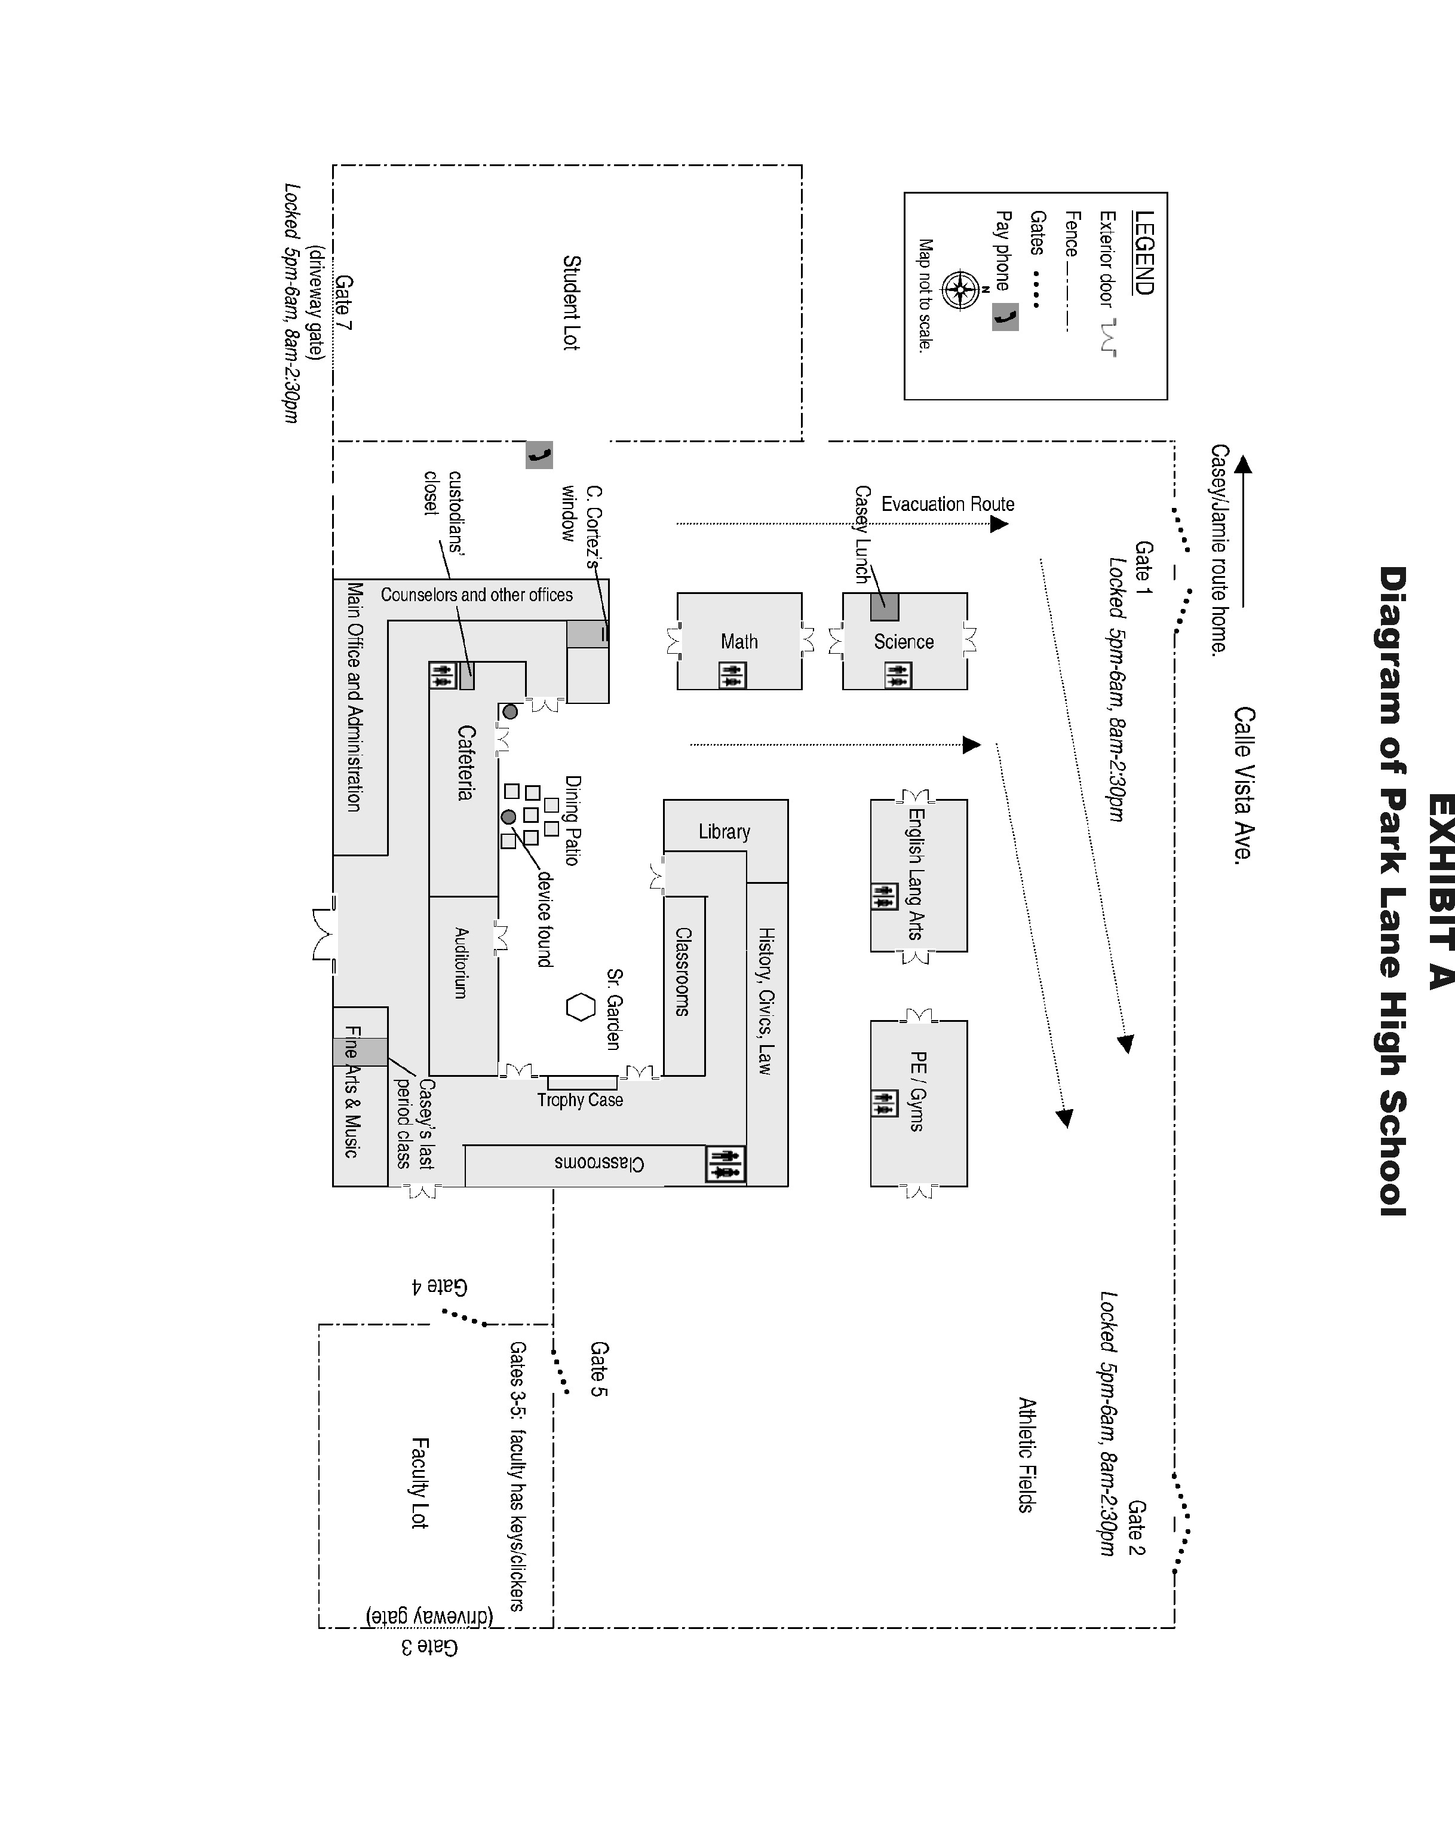
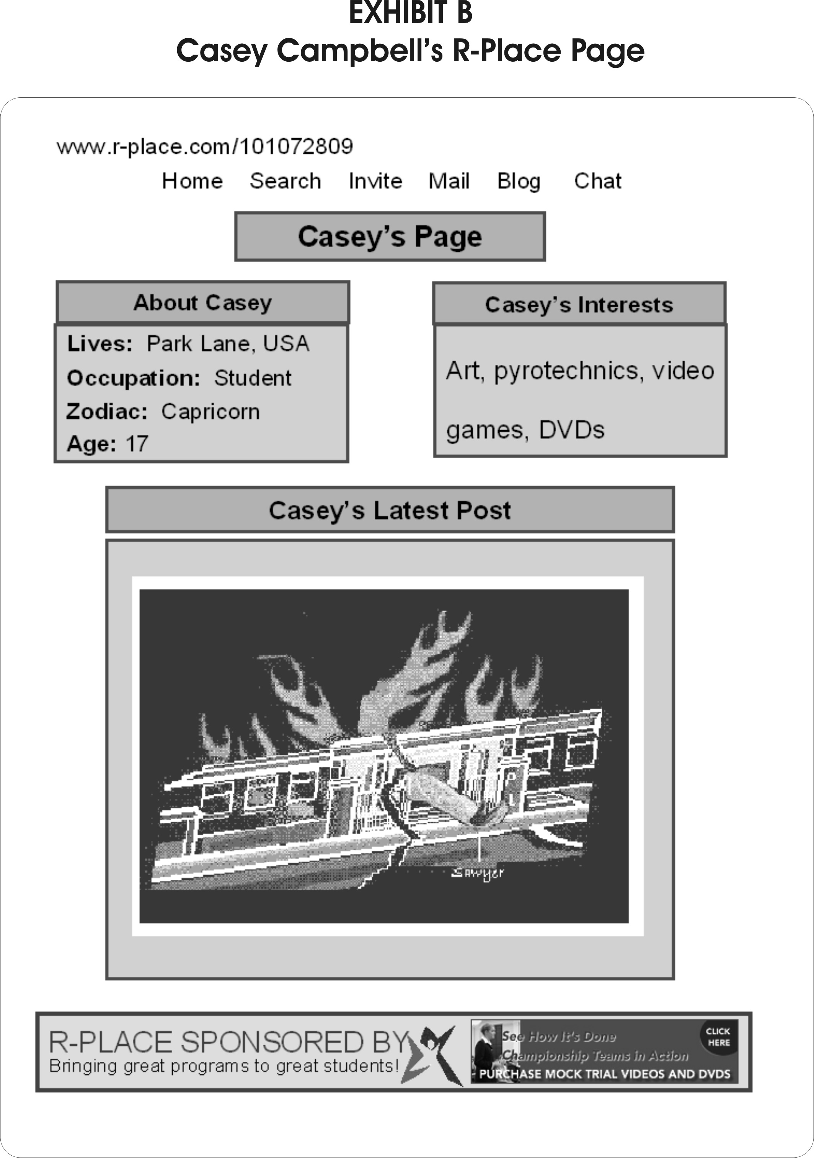
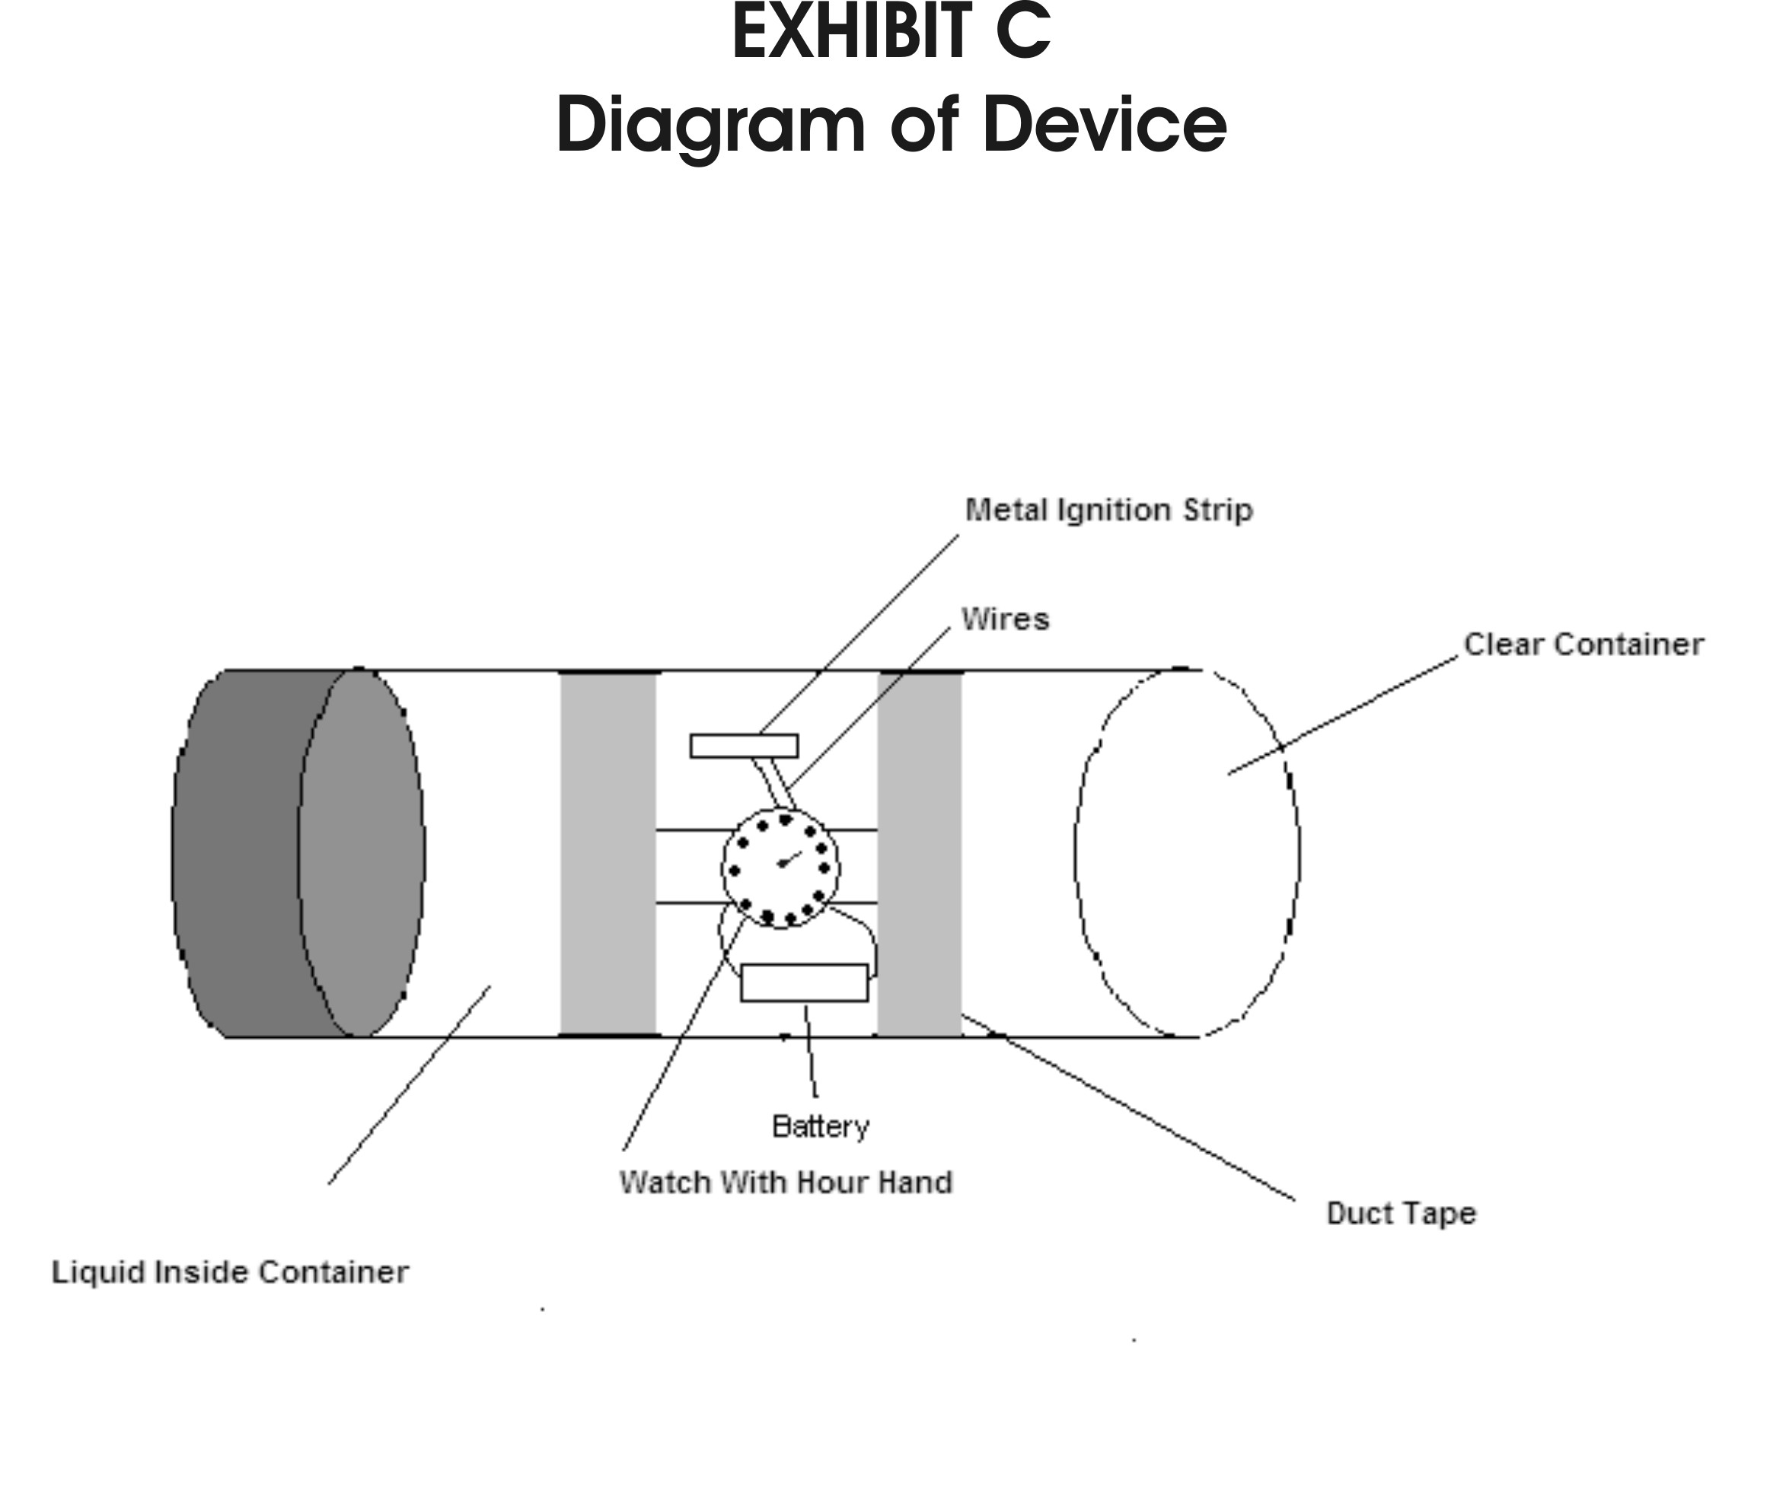

SIMPLIFIED RULES OF EVIDENCE

INTRODUCTION

There are many forms of evidence, e.g., eye witness testimony, expert testimony, official records, personal documents, photographs, video tapes, audio tapes, etc. In the American judicial systems, an elaborate set of rules has been developed to regulate the admission of evidence at trial. The rules of evidence are designed to make the interrogation of witnesses and introduction of evidence effective and efficient for getting at the truth, avoid needless consumption of time, protect witnesses from harassment and undue embarrassment, ensure that only evidence which is relevant, competent and trustworthy is admitted at trial and provide all parties a fair opportunity to present evidence. The rules of evidence are not always easy to comprehend and apply, but all great trial lawyers have a mastery of them.

For purposes of this mock trial competition, the following simplified rules of evidence shall apply.

During the course of a trial, it is the right and the duty of an attorney to make objections to regulate the procedure for, and the admissibility of, evidence in accordance with the rules of evidence. Upon receiving an objection, the Judge will immediately decide whether the objection is accepted or rejected. If the judge agrees with the objection, he or she will “sustain” it. If the judge disagrees with the objection, he or she will “overrule” it. The attorneys are bound by the trial court's rulings on objections.

GENERAL RULES

Leading Questions Not Permitted on Direct Examination.

Leading questions are not permitted during the direct examination of a witness. Leading questions may and should be asked on cross-examination.

A leading question is one that suggests to the witness the answer desired by the examiner, and often suggests a “yes” or “no” answer. On direct examination questions should be open ended and phrased to elicit facts from the witness.

A proper direct question might be phrased “Describe the device that you found in the trash question.” An improper leading question might be phrased: “Isn’t it true that Sawyer has been involved in an earlier incident of bullying?”

Compound Questions Not Permitted.

A question which is composed of two or more separate questions within the question is not permitted.

A compound question asks two or more questions at once. For example, “What time did you arrive at school, who did you see and what did you do there?” is a compound question.

Attorneys Not Allowed to Argue with Witness

Attorneys cannot badger or argue with the witness. Questions may also not be argumentative in tone or manner. Badgering is harassing or asking again and again. While attorneys on cross-examination, that is when questioning the other side’s witnesses, can be forceful and pressing, there is a point in which the attorney goes too far and a judge will sustain an objection for being argumentative.

"Objection. That question is argumentative.”

Narrative Responses Not Permitted.

Questions which call for long narrative responses are not permitted.

While the purpose of direct examination is to get the witness to tell a story, the questions must not be so broadly framed that the witness is allowed to ramble or “narrate” a whole story. Narrative questions are objectionable.

An example of a question which calls for a narrative response is: “Start at the beginning and tell me what happened when you went to search Casey’s house.” A proper objection to this question might be phrased: “Objection, the question calls for a narrative response.”

When a witness launches into a long narrative answer to an otherwise proper question, a proper objection should be made quickly and might be phrased as follows: “Objection, narration.”

Scope of Redirect

Redirect questioning should be limited to the subject matter of the cross-examination.

Examination of a witness on redirect may not go beyond the scope of the cross-examination of the witness. However, the court may permit inquiry into additional matters in the exercise of its sound discretion.

RELEVANCE

Admissibility of Relevant Evidence

All relevant evidence is admissible except as limited by these rules. Evidence which is not relevant is not admissible. “Relevant evidence” means any evidence having a tendency to make the existence of any fact that is of consequence to the determination of the action more probable or less probable than it would be without the evidence.

COMPETENCY

Personal Knowledge

A witness may not testify to a matter unless evidence is introduced sufficient to support a finding that the witness has personal knowledge of the matter or is qualified to testify on the matter as an expert.

A witness must testify only on the basis of facts which the witness has seen, heard or otherwise perceived through his or her senses unless the witness is qualified as an expert witness. For example, a witness could testify from personal knowledge that she viewed Casey’s F-Place webpage, but she would not be permitted to testify that “Everyone at school has seen this web page.” Without laying a foundation to establish the basis for her knowledge about the thoughts of others, the witness has no firsthand knowledge about what all the other persons at school knew.

Impeachment

The credibility of a witness may be attacked by any party, including the party calling the witness.

There are generally considered to be five methods of impeaching a witness: (1) The witness may be shown to be biased (perhaps the witness has a financial interest in the case which may affect his or her credibility as a witness); (2) the witness may be challenged on the basis of mental or sensory deficiencies (how could the witness hear the screeching tires if she is almost deaf and never wears her hearing aid at night?); (3) facts may be introduced to contradict the witness's testimony (the plaintiff says he saw the light turn green, but three nuns and a priest who were crossing the street said the light was red); (4) the witness's character may be attacked (his reputation for truthfulness is not good according to three character witnesses); and (5) the witness's testimony may be discredited by introducing a prior inconsistent statement made by the witness (while telling his story to the police officer at the scene of the accident the witness said he did not have time to honk his horn, now he claims he laid on the horn for two to three seconds trying to get the other driver's attention).

OPINION TESTIMONY

Opinions by Lay Witness

A lay witness may give an opinion if it is rationally based on the perception of the witness and is helpful to a clear understanding of the witness's testimony or the determination of a fact in issue.

As a general rule, the testimony of lay witnesses is restricted to facts, and their opinions are not permitted. Lay witnesses are permitted to offer certain opinions concerning matters which are based on their own common experience. For example, a witness is generally permitted to offer an opinion about the value of his home or about the average miles per gallon achieved by his car.

Opinions by Experts

If scientific, technical, or other specialized knowledge will assist the judge or jury to understand the evidence or to determine a fact at issue, a witness who is qualified as an expert by knowledge, skill, experience, training, or education may testify thereto in the form of an opinion or otherwise.

In this mock trial, both sides have stipulated to the expertise of the two expert witnesses and do not have to be qualified at trial.

Ultimate Issue: No witness may give an opinion about how the case should be decided.

HEARSAY

With certain exceptions, statements that are made outside of the courtroom are not allowed as evidence if they are offered in court to show that the statements are true.

There are many exceptions to the hearsay rule, but the only two that apply to this trial are:

1) that a witness may repeat a statement made by the accused provided that the witness actually heard the statement; and

2) statements that the accused made that go against Casey’s own interest.

Beyond the Scope of the Packet

Questions that ask about, or answers that supply, significant facts not contained in the packet are objectionable. However, minor details regarding a character's role may be asked and added.

Example: "Sawyer, how many brothers and sisters do you have?"

Objection: "Objection, Your Honor, this is beyond the scope of the packet."

Possible Response: "Your Honor, the witness is giving minor details to describe her/his person to the Court, and the facts do not have a significant impact on the outcome of the trial.

INTRODUCTION OF PHYSICAL EVIDENCE

The lawyers may wish to offer as evidence written documents or physical evidence, such as diagrams, F-Space page, or the diagram of the explosive device. Special procedures must be followed before these items can be considered by the Judge and jury as evidence.

1. "Your Honor, I ask that this diagram be marked for identification as Prosecution Exhibit #1." Attorney hands document to bailiff for marking.

2. Attorney shows document to opposing counsel, who may object to the evidence.

3. The attorney hands the document to the witness. "Detective Riley, do you recognize this record as that is marked as Prosecution Exhibit #1?" The witness should say yes. Counsel should then ask the witness to tell the Court what it is. The witness should then explain that it is the diagram of the school.

4. At this point, the attorney may ask the witness questions about the diagram.

5. If the attorney wishes to put the diagram into evidence so that the jury may consider it in its deliberations, counsel says, "Your Honor, I offer this diagram for admission into evidence as Prosecution Exhibit #1 and ask that the Court admit it."

6. The Court will ask the other side if it objects and will then either admit or refuse to admit the diagram. Unless the Court admits the diagram, the jury will not consider it in deliberating on the case.

Special Procedures: Closing Arguments

Prosecution will make the first closing argument, followed by defense counsel, and then, rebuttal by prosecution, if within the time limits.

Special Procedures: Time Guidelines

These time guidelines limit all trials (including the law school seminar).

OPENING STATEMENT 4 minutes

DIRECT EXAMINATION OF
EACH WITNESS 7 minutes (6 minutes for Puyallup trials)

CROSS-EXAMINATION OF
EACH WITNESS 4 minutes (3 minutes for Puyallup trials)

CLOSING ARGUMENTS 4 minutes

SAMPLE OBJECTIONS
Following are some examples of often used objections
Irrelevant Evidence “I object, Your Honor. This testimony is irrelevant to the facts [issues] of this case.”

Leading Questions “Objection. Counsel is leading the witness.” (Remember, this is only objectionable when done on direct examination.)

Narrative Question and/or Response “Objection Counsel's question calls for a narrative” or, “Objection. Witness is giving a narrative response.”

Improper Character Testimony
a. “Objection. The witness's character or reputation has not been put in issue.”
b. “Objection. Only the witness's reputation/character for truthfulness is at issue.”

Beyond the Scope of Direct/Cross Examination: “Objection. Counsel's question goes beyond the scope of the direct/cross examination.”

Hearsay: “Objection. Counsel's question calls for a hearsay response.” Or, “Objection. The witness's answer is based on hearsay.” (If the witness makes a hearsay statement, the attorney should also say,” and I ask that the statement be stricken from the record.”)

Opinion: “Objection. Counsel's question calls for an opinion.”

Lack of Personal Knowledge: “Objection. The witness has no personal knowledge that would enable him/her to answer this question.” Or, “Objection. Lack of foundation.” (This latter objection presupposes that the subject matter of the testimony could be admissible if the examiner first establishes through proper questioning that the witness has the requisite personal knowledge.)

Badgering/Argumentative: “Objection. Counsel is badgering the witness.” Or, “Objection. Counsel is arguing with the witness.”

C. MOCK TRIAL RULES

The mock trials will be governed by these rules.

1. The Stipulated Facts may not be disputed at trial. Additionally, the Judge and jury cannot consider these facts unless the proper witness has given this evidence.

2. Each witness is bound by the facts in the given witness statement. All participants agree that the witness statements are signed and sworn. Witness Statements may not be introduced as evidence, but may be used for impeachment.

Fair additions which (a) are consistent with facts contained in the witness affidavits and (b) do not materially alter the witness’s testimony (that is, do not favor one side over the other) are permitted. If a witness is asked a question on cross-examination which is not deal with in the witness’s statement, the witness may invent an answer favorable to that side’s position. Alternatively, a witness or the witness’s attorney may say, without penalty, that the witness has no firsthand knowledge concerning the matter because the matter is not contained in the witness’s statement.

3. No motions of any type are allowed in this trial.

4. All witnesses must be called to the stand, although each side may decide upon the order in which witnesses are called.

5. If a witness contradicts a fact in the affidavit, the opposition must show this on cross-examination through correct use of the witness statement through impeachment. This procedure is set out in the Rules of Evidence.

6. Students may read other cases, materials, articles, etc., in preparation for mock trial. However, they may only cite the materials given.

7. All participants are expected to display courtroom decorum and good sports-person-like conduct. No food, drink, gum or hats are allowed in the courtroom. Rulings of the Judge and jury are final.

8. During the actual trial, teachers, law students, affiliated non-participating team members, parents and all other observers may not talk to signal, or otherwise communicate with or coach their teams. However, team members may communicate with each other during the trial. The purpose of this rule is to prevent last minute coaching. Law student instructors should sit next to each other in the courtroom in order to minimize claims of coaching.

9. Teams must notify their opposing team of gender choices for witness roles at least one week before their trials. Any subsequent changes must be communicated as soon as is practicable.

10. While this is a competition, emphasis should be focused on the learning process.

Developed by the Oregon Classroom Project and adapted for use in Washington State, with permission, by Margaret E. Fisher, Seattle University School of Law.

